Overview

| **BUS 301** |
| --- |
| BUSINESS & ENTREPRENEURSHIP |

BUS seems like a huge subject because it is. There are many theories that you have to be mindful if you want to complete BUS. However, this is not a difficult subject as it is easy to rack up marks using maths.

Mid

Business

**Business:** Business is any legal activity with the objective of generating profit.

# **Questions:**

## **Q1. What is business?**

Business is an organized effort -

* to produce & sell (or exchange) goods and services
* to satisfy the needs of general people
* to earn profit or to achieve specific objectives (e.g., social welfare).

## **Q2. Write the different types of businesses?**

Based on activities -

1. Manufacturing: Produces goods from raw materials (e.g., garment factories).
2. Trading: Engages in buying and selling goods (e.g., retail stores).
3. Service: Offers intangible products (e.g., consulting, IT services).

Based on size -

1. Small Business: Limited in scope, investment and employees. (e.g., local shops)
2. Medium Business: Moderate scaled businesses with regional presence.
3. Large Business: Significant investments in various different sectors. Often multinational.

Based on ownership -

1. Sole proprietorship: Owned and managed by a single person.
2. Partnership: Owned by two or more people sharing profits, losses and responsibilities.
3. Corporation: A separate legal entity owned by shareholders.
4. Cooperative: Owned and operated by a group of people for mutual benefit.

## **Q3. Write pros and cons of each business type based on ownership.**

|  | Pros | Cons |
| --- | --- | --- |
| Sole Proprietorship | 1. Cheapest business to form 2. No business tax | 1. Risk of unlimited liabilities 2. Business life is limited by the owner's life. |
| Partnership | 1. Comparatively inexpensive to form. 2. No business tax. | 1. Risk of unlimited liabilities for the general partner but limited liability for limited partners. 2. Business life is limited by the general partner’s life. |
| Corporation | 1. Limited liabilities as a corporation is a different legal entity. 2. Easier to raise a lot of investment funds. 3. A corporation can be active forever. | 1. Hardest and costliest to set up a corporation. 2. Since a corporation is a legal entity. It also has to pay taxes. |

## **Q4. What is Entrepreneurship?**

Entrepreneurship refers to the process of identifying, developing, and managing a business venture to make a profit. It involves **innovation, risk-taking, and resource management** to create and grow a business.

Financial Decision Making

**Finance:** Finance is the study and management of money, investments and other financial instruments. It involves activities such as budgeting, borrowing, lending, investing and risk management.

**Liquidity:** Liquidity refers to how fast we can convert an asset into cash in the fair market value.

# **Questions:**

## **Q1. What is the Time Value of Money?**

The Time Value of Money (TVM) means that **money today is worth more than the same amount of money in the future**. This is because money can be invested or earn interest, increasing its value over time.

Key reasons for the difference between Present Value (PV) and Future Value (FV) are -

1. **Uncertainty & Risk:** Future cash flows are uncertain, so its value is adjusted for risk.
2. **Inflation:** The value (purchasing power) of money reduces in the future.
3. **Opportunity Cost:** Money today can be invested to earn interest, so it will be worth more than in future.
4. **Interest Rates:** Money grows over time with interest, where future money can be reduced to its present value.

## **Q2. What is Compounding & Discounting?**

Compounding is the process of growing a present sum of money into a larger amount in the future. The formula for calculating the future value of money is

Where, FV = future value

PV = present value

i = interest/discount rate

n = number of years

Discounting the reverse of compounding.

We use compounding to find the future value of money from present value and discounting to find the present value of money from future value.

## **Q3. What is the Payback Period?**

Payback period is the time required for an investment to recover its initial cost.

We try to find the payback period to find out how long it will take to recoup the invested money. Greatly helpful for evaluating investment risk and budgeting. If a company wants to take up a single project it should first set up **a cut-off period**. If the payback period is less than the cut-off period, it will **accept** the project, otherwise it won’t.

If a company has to choose the project between multiple projects, then it should always choose the one with the least payback period.

## **Q4. What are the advantages & limitations of the Payback Period?**

Advantages:

* Simplicity & Easy to Understand.
* Focus on Liquidity & Risk Reduction.
* Useful for High-Risk Projects.
* Quick Comparison Between Projects.
* Effective for Small Businesses & Startups, as they have limited capital, they can calculate the returns of the investment for different projects easily.

Limitations:

* Ignores the Time Value of Money (TVM).
* Ignores Cash Flows After Payback Period.
* Does not Account for Risk and Uncertainty.
* Fails to Differentiate Between Projects of Similar Payback Periods.
* Preference for Short-Term Projects only.

## **Q5. What is the Net Present Value?**

NPV is the sum of all present values of future cash flows discounted at a specific rate minus the initial investment.

We try to find the NPV to find out what is the present value of my future cash in-flows. Greatly helpful for evaluating possible profits. It is also much simpler than PBP because we don’t have to set any limit for evaluating NPV.

If a company has to choose between multiple projects, then it should always choose the one with a positive and higher NPV.

## **Q6. What are the advantages & limitations of the NPV?**

Advantages:

* Considers Time Value of Money.
* Uses all cash flows.
* Easier decision making.
* Considers risk through a discount rate.

Limitations:

* Difficult to determine discount rate.
* Ignores project size.
* Difficult for comparing different project durations.

## **Q7. What is the Internal Rate of Return (IRR)?**

IRR is the discount rate at which the NPV becomes zero.

We try to find the IRR to find out the discount rate which will make our NPV zero. A company will set a cost of capital and if the IRR is higher, then the company will accept the project.

## **Q8. What are the advantages & limitations of the IRR?**

Advantages:

* Considers Time Value of Money.
* Uses all cash flows.
* Easier decision making.
* Does not require a predetermined discount rate.
* Useful for investment comparison.

Limitations:

* Assumes cash flows are reinvested at IRR.
* Gives multiple IRR for any cash flow changes.
* Ignores project scale.
* Difficult to calculate without technology.
* Remember, PBP gives us a time, NPV gives us an amount of money and IRR gives us a percentage.

# **Maths:**

## **P1. Moumita is planning to invest in a project with following cash flow projections. Calculate The Payback Period. If her cut-off year is 3 years, should she take the project?**

**Initial investment: $15,000**

**Year 1: $4,000**

**Year 2: $5,000**

**Year 3: $3,000**

**Year 4: $4,000**

⇒

| **Year** | **Cash Flow** | **Cumulative Cash Flow** |
| --- | --- | --- |
| 1 | 4,000 | 4,000 |
| 2 | 5,000 | 9,000 |
| 3 | 3,000 | 12,000 |
| 4 | 4,000 | 16,000 |

yr

As, Payback period > Cut-off year, Moumita should reject the project.

## **P2. Anisha is planning to invest in a project with following cash flow projections. Calculate The Payback Period. If Her cut-off year is 3 years, should she take the project? (Equal Cash Flow)**

**Initial investment: $15,000**

**Year 1: $4,000**

**Year 2: $4,000**

**Year 3: $4,000**

**Year 4: $4,000**

⇒

| **Year** | **Cash Flow** | **Cumulative Cash Flow** |
| --- | --- | --- |
| 1 | 4,000 | 4,000 |
| 2 | 4,000 | 8,000 |
| 3 | 4,000 | 12,000 |
| 4 | 4,000 | 16,000 |

**‘OR’**

When the cash flows are equal each year, we can use an easier formula,

Here,

As, Payback period > Cut-off year, Anisha should reject the project.

## **P3. Sayem is planning to invest BDT 300,000. He was presented with two Projects of equal size and risk. If he takes decision based on Payback period, which project should he choose?**

| **Year** | **Project A** | **Project B** |
| --- | --- | --- |
| 0 | (300,000) | (300,000) |
| 1 | 70,000 | 120,000 |
| 2 | 70,000 | 100,000 |
| 3 | 70,000 | 30,000 |
| 4 | 70,000 | 30,000 |
| 5 | 70,000 | 30,000 |

⇒

For Project A

| **Year** | **Cash Flow** | **Cumulative Cash Flow** |
| --- | --- | --- |
| 1 | 70,000 | 70,000 |
| 2 | 70,000 | 140,000 |
| 3 | 70,000 | 210,000 |
| 4 | 70,000 | 280,000 |
| 5 | 70,000 | 350,000 |

Here,

For Project B

| **Year** | **Cash Flow** | **Cumulative Cash Flow** |
| --- | --- | --- |
| 1 | 120,000 | 120,000 |
| 2 | 100,000 | 220,000 |
| 3 | 30,000 | 250,000 |
| 4 | 30,000 | 280,000 |
| 5 | 30,000 | 310,000 |

yrs

Sayem should take Project A based on payback period, because PPA < PPB

## **Q4. Anisha is planning to invest in a project with following cash flow projections. Calculate the NPV assuming the discount rate of 10%. Should she take the project?**

**Initial investment: $15,000**

**Year 1: $4,000**

**Year 2: $5,000**

**Year 3: $3,000**

**Year 4: $4,000**

⇒ we know,

Anisha should reject the proposal.

## **Q5. Anisha is planning to invest in a project with following cash flow projections. Calculate the NPV assuming the discount rate of 10%. Should she take the project?**

**Initial investment: $15,000**

**Year 1: $5,000**

**Year 2: $5,000**

**Year 3: $5,000**

**Year 4: $5,000**

⇒ we know,

**‘OR’**

When the cash flows are equal each year, we can use an easier formula

Anisha should accept the proposal.

## **Q6. Nasim is planning to invest in a project with following cash flow projections. Calculate Net Present Value if Discount Rate is 13%.**

**Initial investment: $150,000**

**Year 1: $100,000**

**Year 2: $60,000**

**Year 3: $50,000**

**Year 4: $60,000**

⇒ we know,

## **Q7. Rahim is planning to start a new car business. The business will require BDT 200,000 to start. He plans to continue the business for 5 years. Following are the cash flow projections.**

**Year 1: $10,000**

**Year 2: $20,000**

**Year 3: $30,000**

**Year 4: $40,000**

**Year 5: $200,000**

**Should he take the project if the discount rate is 15%. Take decisions based on NPV.**

⇒ we know,

He shouldn’t take the project.

## **Q7. Anisha is planning to invest in a project with following cash flow projections. Calculate IRR. If the cost of capital is 8%, should she take the project?**

**Initial investment: $15,000**

**Year 1: $6,000**

**Year 2: $5,000**

**Year 3: $3,000**

**Year 4: $4,000**

⇒ NPV at 10%

NPV at 6%

now,

She should take on the project.

## **Q8. Sayem is planning to invest BDT 800,000. He was presented with two Projects. If he takes decision based on IRR, which project should he choose?**

| **Year** | **Project A** | **Project B** |
| --- | --- | --- |
| 0 | (800,000) | (800,000) |
| 1 | 140,000 | 250,000 |
| 2 | 150,000 | 260,000 |
| 3 | 160,000 | 160,000 |
| 4 | 250,000 | 120,000 |
| 5 | 260,000 | 100,000 |

⇒ For project A,

NPV at 6%

NPV at 5%

now,

For project B,

NPV at 5%

NPV at 4%

now,

Accept Project A because of the higher IRR.

Fundamentals of Management

**Management:** Management is the process of **planning, organizing, leading and controlling** resources to achieve specific goals efficiently in an organization.

* Planning: Setting goals and deciding how to achieve them.
* Organizing: Allocating resources and assigning tasks.
* Leading: Motivating employees and properly handling resources.
* Controlling: Monitoring and making progress.

# **Questions:**

## **Q1. Explain different organizational structures and draw necessary figures.**

⇒



Advantages:

* Clear hierarchy and reporting structure.
* Increases efficiency and expertise.
* Easier to manage due to centralized decision making.

Disadvantages:

* Limited collaboration between departments.
* Decision making can be slow if cross-departmental inputs are required.
* Employees may prioritize departmental goals over organizational goals.

Best fit:

* Organizations with stable environments
* Manufacturing companies
* Firms requiring high specialization.



Advantages:

* Focuses on specific markets, demographics
* Easier performance measurement and accountability.
* Encourages innovation within divisions.

Disadvantages:

* Duplicates resources.
* High costs due to duplicacy.
* Divisions may compete instead of cooperating.

Best fit:

* Large organizations with diverse products, customer bases, geographic locations.

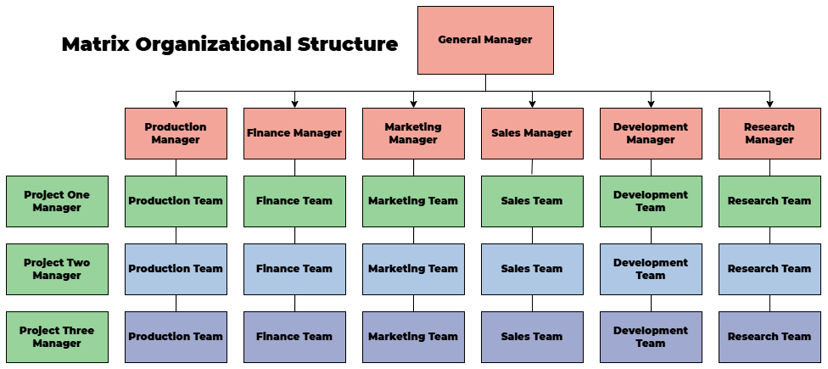

Advantages:

* Promotes efficient resource utilization by sharing employees.
* Enhances flexibility and adaptability.
* Encourages collaboration across departments.

Disadvantages:

* Complex reporting relationships.
* Conflicts may arise due to unclear authority.
* Decision making may be time consuming.

Best fit:

* Suitable for project-driven industries.

Hierarchical Organizational Structure:

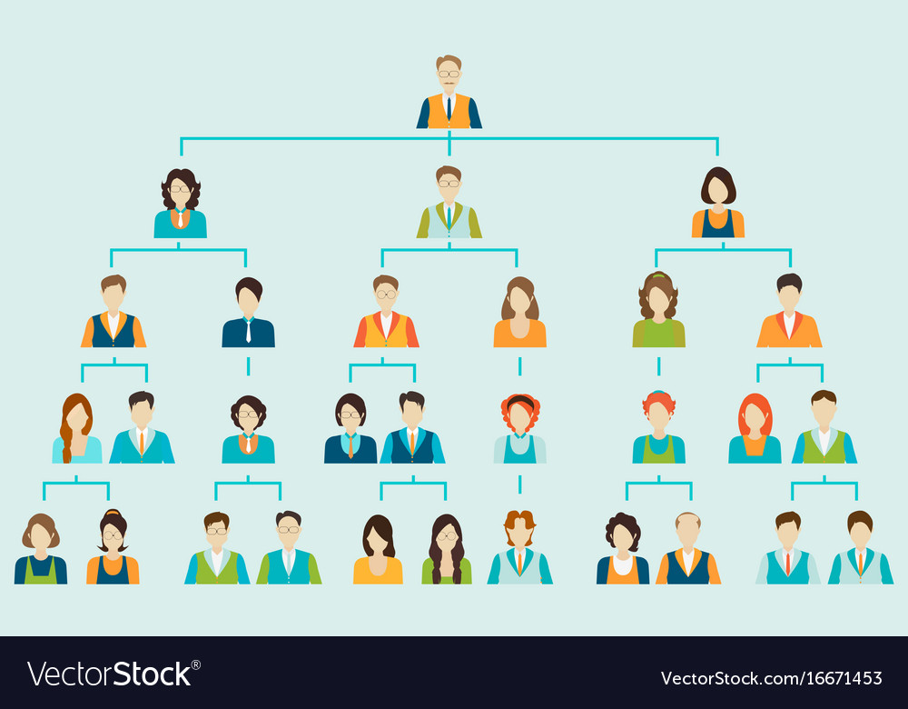

Advantages:

* Establishes clear authority and responsibility.
* Ensures consistency in decision making.

Disadvantages:

* Slower decision making.
* Limits cross-department communication.
* Can reduce employee autonomy.

Best fit:

* Large organizations, government agencies and military institutions.

Risk

**Risk:** Risk refers to the possibility that the actual return on an investment might not align with the expected return. There are:

* Market Risk: This refers to the broader risk that affects the entire market. It can happen due to economic recessions, interest rate changes or a sudden environmental shift. This risk is unavoidable.
* Business Risk: This risk is specific to a company or an industry. It can happen due to poor management, product recalls or labor strikes. This risk is avoidable.

Measures of risks:

* Standard Deviation: Square root of variance. Used in finance to measure volatility. Higher the deviation, higher the risk.
* Coefficient of Variation: Ratio of SD and mean. Used to compare between different assets. Higher the CV, higher the risk.

# **Questions:**

## **Q1. Find out which of the projects is riskier.**

| **Year** | **Project A** | **Project B** |
| --- | --- | --- |
| 1 | 100 | 500 |
| 2 | 120 | 530 |
| 3 | 80 | 550 |
| 4 | 130 | 480 |

⇒

| **Year** | **Project A** | **Project B** |  |  |  |  |
| --- | --- | --- | --- | --- | --- | --- |
| 1 | 100 | 500 | 107.5 | 515 | 56.25 | 225 |
| 2 | 120 | 530 | 156.25 | 225 |
| 3 | 80 | 550 | 756.25 | 1225 |
| 4 | 130 | 480 | 506.25 | 1225 |
| SUM | | | | | 1475 | 2900 |

Now we find the standard deviation,

Since, the SD of Project B is higher, it is the riskier project.

## **Q2. Compare the risk associated with investment options A and B using standard deviation and coefficient of variation. Which option is riskier?**

| **Pi** | **Project A** | **Project B** |
| --- | --- | --- |
| 0.3 (30%) | 50 | 80 |
| 0.6 (60%) | 60 | 100 |
| 0.1 (10%) | 100 | 150 |

⇒

| **Pi** | **Project A** | **Project B** |  |  |  |  |
| --- | --- | --- | --- | --- | --- | --- |
| 0.3 | 50 | 80 | 61 | 99 | 36.3 | 108.3 |
| 0.6 | 60 | 100 | 0.6 | 0.6 |
| 0.1 | 100 | 150 | 152.1 | 260.1 |
| SUM | | | | | 189 | 369 |

Now we find the standard deviation,

Now, we find the coefficient of variation,

Since, CVA is higher, project A is riskier.

Final

Accounting

# **Transaction:**

**Asset**⇒ Assets are any object of value owned by a company.

**Liabilities** ⇒ Liabilities are claims against assets.

**Owner’s Equity** ⇒ Owner’s Equity represents the ownership claim on total assets. Capital, Revenue, Expenses are part of owner equity.

# **Questions:**

## **Ques 1:**

A company has the following financial data at the beginning of the year:

* Total Assets: $120,000
* Total Liabilities: $50,000
* Total Owner’s Equity: $70,000

During the year, the company:

* Purchased equipment for $30,000, paid $10,000 in cash, and took a loan for the remaining amount.
* Generated $40,000 in revenue.
* Paid off $5,000 of its loan.
* Declared and paid dividends of $8,000 to shareholders.

Required:

1. Using the accounting equation (Assets = Liabilities + Owner’s Equity), calculate

the company’s updated financial position after each transaction.

2. Determine the final values of the company’s liabilities, and owner’s equity at the end of the year.

| Transaction Num | Assets | | = | Liabilities | + | Owner’s Equity | Comment |
| --- | --- | --- | --- | --- | --- | --- | --- |
| Equipment | Cash | Loan |
| 1 | 30,000 | (10,000) | 20,000 |  |  |
| 2 |  | 40,000 |  | 40,000 | Revenue |
| 3 |  | (5,000) | (5,000) |  |  |
| 4 |  | (8,000) |  | (8,000) | Dividend |
| Yearly Change | 30,000 | 17,000 | 15,000 | 32,000 |  |
| Initial Balance | 120,000 | | 50,000 | 70,000 |  |
| Total | \newcommand{\doubleunderline}[1]{\underline{\underline{#1}}}    \doubleunderline{167,000} %ce88d904-017f-400a-89e1-d47dccc5b714 | | \newcommand{\doubleunderline}[1]{\underline{\underline{#1}}}    \doubleunderline{167,000} %ce88d904-017f-400a-89e1-d47dccc5b714 | | |  |

Income Statement: Study this after learning about income statements from here.

| **Company**  **Income Statement**  **For the month ended** | | |
| --- | --- | --- |
| Income |  |  |
| Service Revenue |  | $ 40,000 |
| Expenses |  | $ 0 |
| Net income |  | $ 40,000 |

## **Ques 2:**

At the beginning of the year, XYZ Corporation had the following account balances:

* Cash: $40,000
* Accounts Receivable: $25,000
* Equipment: $60,000
* Accounts Payable: $15,000
* Bank Loan: $30,000
* Owner’s Equity: $80,000

During the year, the following transactions took place:

1. Purchased additional equipment for $20,000 in cash.
2. Collected $15,000 from customers on accounts receivable.
3. Paid $5,000 towards the bank loan.
4. Provided services worth $50,000, out of which $35,000 was received in cash and $15,000 on account.
5. Paid $10,000 in dividends to the owners.

Required:

1. Using the accounting equation (Assets = Liabilities + Owner’s Equity), show

how each transaction impacts the Company.

2. Calculate the final balances for total Net income, owner’s equity, financial positions after all the transactions.

| Transaction Num | Assets | | | = | Liabilities | | + | Owner’s Equity |
| --- | --- | --- | --- | --- | --- | --- | --- | --- |
| Equipment | Cash | Account Receivable | Loan | Accounts Payable |
| 1 | 20,000 | (20,000) |  |  |  |  |
| 2 |  | 15,000 | (15,000) |  |  |  |
| 3 |  | (5,000) |  | (5,000) |  |  |
| 4 |  | 35,000 | 15,000 |  |  | 50,000  (Revenue) |
| 5 |  | (10,000) |  |  |  | (10,000)  Dividend |
| Yearly Change | 20,000 | 15,000 | 0 | (5,000) |  | 40,000 |
| Initial Balance | 60,000 | 40,000 | 25,000 | 30,000 | 15,000 | 80,000 |
| Total | \newcommand{\doubleunderline}[1]{\underline{\underline{#1}}}    \doubleunderline{160,000} %ba56ff93-ef1c-429a-9abb-2258bc89f87d | | | \newcommand{\doubleunderline}[1]{\underline{\underline{#1}}}    \doubleunderline{160,000} %ba56ff93-ef1c-429a-9abb-2258bc89f87d | | | |

Income Statement: Study this after learning about income statements from here.

| **XYZ Corporation**  **Income Statement**  **For the month ended** | | |
| --- | --- | --- |
| Revenues |  |  |
| Service Revenue |  | $ 65,000 |
| Expenses |  | $ 0 |
| Net Income |  | $ 65,000 |

## **Ques 3:**

XYZ Corporation engaged in the following transactions during the year:

1. Owner invested $100,000.
2. Received a loan of $50,000 from ABC Bank.
3. Sold goods worth $20,000 to customers, who will pay within 30 days.
4. Purchased inventory worth $15,000 from Supplier Co., with payment due in 60 days.
5. Paid $8,000 in cash for office rent to Landlord Corp.
6. Provided services worth $10,000 to clients, who paid in cash.
7. Paid $5,000 in interest to ABC Bank on the loan.

Required:

1. For each transaction, explain how the accounting equation (Assets = Liabilities + Owner’s Equity) is affected by the interaction between the parties.

2. Using the accounting equation, determine the impact on XYZ Corporation’s net

income, equity and financial position after all the transactions.

| Transaction Num | Assets | | | = | Liabilities | | Owner’s Equity |
| --- | --- | --- | --- | --- | --- | --- | --- |
| Inventory | Cash | Account Receivable | Loan | Accounts Payable |
| 1 |  | 100,000 |  |  |  | 100,000 (investment) |
| 2 |  | 50,000 |  | 50,000 |  |  |
| 3 |  |  | 20,000 |  |  | 20,000 (Revenue) |
| 4 | 15,000 |  |  |  | 15,000 |  |
| 5 |  | (8,000) |  |  |  | (8,000) (Expense) |
| 6 |  | 10,000 |  |  |  | 10,000 (Revenue) |
| 7 |  | (5,000) |  |  |  | (5,000) |
| Yearly Change | 15,000 | 147,000 | 20,000 | 50,000 | 15,000 | 117,000 |
| Total | \newcommand{\doubleunderline}[1]{\underline{\underline{#1}}}    \doubleunderline{182,000} %969fbdb5-c7b7-4ad8-9c85-7630cbb00e19 | | | \newcommand{\doubleunderline}[1]{\underline{\underline{#1}}}    \doubleunderline{182,000} %969fbdb5-c7b7-4ad8-9c85-7630cbb00e19 | | |

Income Statement: Study this after learning about income statements from here.

| **XYZ Corporation**  **Income Statement**  **For the month ended** | | |
| --- | --- | --- |
| Revenues |  |  |
| Goods sold | $ 20,000 |  |
| Service Revenue | 10,000  —----------+ |  |
| Total Revenues |  | $ 30,000 |
| Expenses |  |  |
| Inventory Expense |  | $ 15,000  —----------- |
| Net Income |  | $ 15,000 |

## **Ques 4:**

Assuming ABC Company had the following balances at the beginning of the month:

* Total Assets: $100,000
* Total Liabilities: $40,000
* Total Owner’s Equity: $60,000.

ABC Company recorded the following transactions during the month of September:

1. Purchased raw materials worth $12,000 from Supplier X on credit.
2. Paid $3,000 cash to Maintenance Services Inc. for equipment repairs.
3. Received $25,000 in cash from Customer Y for services rendered.
4. Issued $10,000 worth of shares to new investors.
5. Repaid $5,000 of an outstanding loan to Bank Z.
6. Paid $2,500 in wages to employees.
7. Collected $8,000 on accounts receivable from Customer.

Required:

1. Determine the accounting equation impact in the accounting equation (Assets = Liabilities + Owner’s Equity)

2. Determine Profit or loss, owners’ equity.

| Transaction Num | Assets | | | = | Liabilities | | Owner’s Equity |
| --- | --- | --- | --- | --- | --- | --- | --- |
| Material | Cash | Account Receivable | Loan | Accounts Payable |
| 1 | 12,000 |  |  |  | 12,000 |  |
| 2 |  | (3,000) |  |  |  | (3,000) |
| 3 |  | 25,000 |  |  |  | 25,000 |
| 4 |  | 10,000 |  |  |  | 10,000 |
| 5 |  | (5,000) |  | (5,000) |  |  |
| 6 |  | (2,500) |  |  |  | (2,500) (Wage) |
| 7 |  | 8,000 | (8,000) |  |  |  |
| Yearly Change | 12,000 | 32,500 | (8,000) | (5,000) | 12,000 | 29,500 |
| Initial Balance | 100,000 | | | 40,000 | | 60,000 |
| Total | \newcommand{\doubleunderline}[1]{\underline{\underline{#1}}}    \doubleunderline{136,500} %0897da64-ab2b-4252-87eb-ba23f5e7d359 | | | \newcommand{\doubleunderline}[1]{\underline{\underline{#1}}}    \doubleunderline{136,500} %0897da64-ab2b-4252-87eb-ba23f5e7d359 | | |

Income Statement: Study this after learning about income statements from here.

| **ABC Company**  **Income Statement**  **For the month ended** | | |
| --- | --- | --- |
| Revenues |  |  |
| Service Revenue |  | $ 33,000 |
| Expenses |  |  |
| Raw Material Expense |  | $ 12,000  —----------- |
| Net Income |  | $ 21,000 |

# **Financial Statement:**

After making a tabular analysis, four financial statements are prepared from the transactions (we only care about two).

**Income statement ⇒** It presents the revenues and expenses and resulting net income or net loss of a company for a specified period of time.

**Balance sheet ⇒** It reports the assets, liabilities, and owner’s equity of a business at a specific date.

**Balance Sheet:**

Business Plan

# **Mission & Vision:**

A mission is a statement of purpose. It describes what a company does, who it serves, and how it serves them. The mission guides the company actions.

A vision is a statement of future direction. It describes what a company wants to achieve in the future. The vision drives and motivates the company to achieve what it wants.

| Aspect | Mission | Vision |
| --- | --- | --- |
| Focus | Present | Future |
| Purpose | Describes the purpose and values of the company | Describes the future goals. |
| Timeframe | Short to medium timeframe | Long term |
| Audience | Employees, management and shareholders | Buyers, customers, investors |
| Content | Focus on current operations | Focus on the future impact of current operations. |

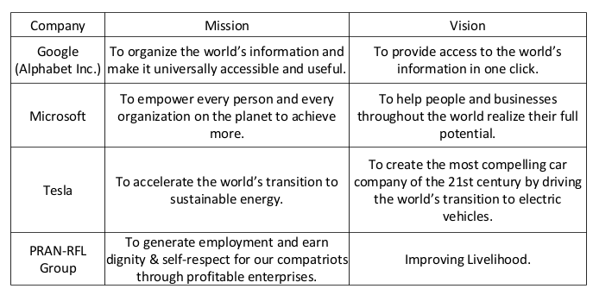

# **Customer Segmentation:**

Customer segmentation means dividing a customer base into distinct groups to better target them in the future. There are 4 ways we can segment customers. They are:

Demographic: A portion of the population. It includes age group, income level and especially gender. By segmenting customers based on demographic, we can tailor-suit our products according to their wishes. Example: A skincare brand may go for females as females typically tend to spend more on cosmetics.

Psychographic: Customers’ lifestyle, fears, values, motivation. Knowing about them can make a company choose a different style of advertisements and products. A shopping mart may prefer organic branding because of people’s perception of nature's goodness.

Behavioral: Is the customer tech savvy or tech illiterate? Are they fit or flexible or casual? Do they prefer adrenaline boosts or slow grinds? Behavioral data can help a business learn more about their customers. Example: Some people may prefer simplicity in their softwares while others prefer more customizability.

Geographic: A customers’ location, where they live, where they mostly stay. Geographic segmentation is the largest segmentation and helps a business decide where they want to set their eyes on. Example: A clothing company may advertise warm clothes during winter and light clothes during summer.

# **Targeting:**

Targeting means influencing or manipulating a customer into buying your products. There are 2 ways we can target customers.

ATL: ATL means above the line targeting. It mainly targets all sorts of people regardless of customer segmentation. TV ads, billboards, and posters are some ATL targeting.

BTL: BTL means below the line targeting. It targets different demographics of people. Like social media ads can be shown only to people who are interested in a product. A loyalty program for your long term customers. Discounts to target middle or below class customers.

# **Buyer’s Persona:**

A buyer’s persona is a distinct study about an individual which maps out his behaviors which companies can target later on.

|  | Profile 1 | Profile 2 | Profile 3 |
| --- | --- | --- | --- |
| Young Adult | Millennial | Gen X |
| Age | 18 - 25 | 25 - 30 | 35+ |
| Profession | Students | Job Holder (Entry) | Job Holder (Experienced) |
| Income | Low  (10k - 20k) | Medium  (40k - 100k) | High  (100k+) |
| Preference | Adventurous | Adventurous/Relaxing | Relaxing |
| Spending Pattern | Low to Medium | Medium to High | High |
| Media | BTL: Social Media | Both | ATL: TV ads |

|  | Junaid | Ema | Shima |
| --- | --- | --- | --- |
| Young Adult | Young Adult | Young Adult |
| Age | 18 - 25 | 18 - 25 | 18 - 25 |
| Profession | Students | Job Holder (Entry) | Job Holder (Experienced) |
| Income | Nil | Medium  (5k - 10k) | High  (10k+) |
| Preference | Adventurous | Relaxing | Homebound |
| Spending Pattern | Low to Medium | Low to Medium | High |
| Media | BTL: Social Media | BTL: Social Media | BTL: Social Media |

# 

# **Porter’s Five Forces:**

Porter's Five Forces model can be used in the business plan or industry analysis section. It helps to understand how competitive an industry is and how much profit a business can make. This model looks at five important factors that affect competition and success in the market.

**Threat of Substitutes:** An industry is usually more attractive when there are fewer substitute products or services. This force looks at how easily customers can switch to a different product that meets the same need.

Example: Zoom video calls can replace the need for traveling to meetings, which can reduce the use of ride services like Uber.

**Threat of New Entrants:** Industries are usually more attractive when it's hard for new companies to enter. This force looks at how easy or difficult it is for new businesses to join the industry and take away market share.

If it's hard to enter, existing companies are safer. Barriers that make entry difficult include:

* Economies of scale (big companies produce at lower cost)
* High capital requirements (need a lot of money to start)
* Limited access to distribution channels (hard to get products to customers)
* Government rules and legal protections (licenses, patents, etc.)

**Rivalry Among Existing Firms:** This force looks at how strong the competition is between the companies already in the industry. High competition makes it harder for companies to grow and earn profits. Rivalry becomes intense when:

* There are many companies of similar size
* Products or services are very similar, with little difference
* The industry is growing slowly
* Fixed costs are high, so companies lower prices to keep selling more

**Bargaining Power of Suppliers:** Industries are usually more attractive when suppliers have less power. This force looks at how much control suppliers have over prices, quality, and availability of materials. If a supplier provides low-quality parts, the final product suffers, and the manufacturer may have to lower its prices. Factors that increase supplier power include:

* Only a few suppliers for an important component
* High switching costs (expensive or difficult to change suppliers)
* No good substitute for the supplier’s product
* Supplier might start selling directly to customers (forward integration)

Example: Microsoft and Intel have strong power over PC manufacturers because they supply essential software and hardware.

**Bargaining Power of Buyers:** Industries are more attractive when buyers have less power. This force looks at how much influence customers have over pricing and terms. When buyers have more power, they can demand lower prices or better quality. Factors that increase buyer power include:

* A few large buyers who purchase in big volumes
* Products are standardized and similar across sellers
* Customers can easily switch to other companies
* Buyers might start making the product themselves (backward integration)

Example: Supermarkets often have strong bargaining power when dealing with farmers or suppliers because they buy in large amounts and can negotiate better prices.

Analysis

# **SWOT:**

SWOT means Strengths, Weaknesses, Opportunities, Threats. Let’s go over each:

## **Strengths:**

A company can have their internal strengths which lets them appeal to investors, gain a competitive advantage. These help the company grow. This also helps a company to

* Gain more customers.
* Retain existing customers.
* Expand into new markets.

**Characteristics:**

* Things the company is already good at.
* Resources the company owns or controls.
* Special skills or advantages.
* Positive internal factors.

**Categories:**

* Tangible: Physical assets like office equipment, cash.
* Intangible: Brand image, intellectual property, company culture.
* Human: Talented staff, great leaders and capable customer service.
* Organizational: Smooth operations.

## 

## **Weakness:**

Weaknesses are the internal limitations that hinder an organization's ability to perform effectively or gain a competitive edge. Recognizing weaknesses allows an organization to

* fix internal problems.
* strengthen capabilities.
* minimize potential damage.

**Characteristics:**

* Things the company is missing or not good at.
* Areas that need improvement.
* Causes of customer dissatisfaction.
* Negative internal factors.

**Categories:**

* Resource constraints: Lack of cash, skilled people or modern technology.
* Operational Flaws: Poor management.
* Reputational Issues: Bad image, customer complaints.
* Strategic Gaps: Lack of vision, outdated business models.

## **Opportunities:**

Opportunities are external factors or trends that an organization can exploit to its advantage for growth, expansion, or improvement. Spotting and acting on opportunities helps companies to

* Innovate and grow
* stay ahead of the competition.

**Characteristics:**

* Arise from the external environment.
* Often related to trends, changes, or gaps in the market.
* Not within the company's control-but can be capitalized on.
* Can lead to competitive advantage if acted upon quickly.

**Sources:**

* Market Trends: Growing demand, consumer lifestyle shifts
* Technological Innovations: New platforms, AI automation.
* Regulatory Changes: Tax benefits, trade agreements
* Strategic Alliances: Collaborations, joint ventures

## **Threats:**

Threats are external challenges that could negatively affect an organization's

performance, profitability, or sustainability. Identifying threats early helps a

company develop

* contingency plans
* mitigate risks
* remain resilient in a changing environment.

**Characteristics:**

* Arise from the external environment.
* Often unpredictable or difficult to control.
* Can pose risks to revenue, market share, or operations.
* Need proactive planning to minimize impact.

**Sources:**

* Economic Factors: Inflation, recession, currency fluctuation
* Political/Legal Changes: New laws, trade restrictions
* Technological Disruption: Emerging tech making current products obsolete
* Social Shifts: Changing customer behavior or preferences
* Competitive Pressure: New entrants, aggressive pricing.

## **Example**

"GreenGlow" is a fast-growing Bangladeshi skincare brand that focuses on natural, organic, and eco-friendly products. It started as a small online shop during the COVID-19 pandemic, offering handmade soaps, facial oils, and scrubs. Within two years, it expanded to physical retail outlets in Dhaka and Chattogram. The company emphasizes cruelty-free products, eco-friendly packaging, and sustainability. GreenGlow's target market is young urban women aged 18-35 who are becoming more health-conscious and environmentally aware. The brand uses social media influencers to promote its products and has strong customer engagement online. However, the company is now facing stiffer competition as global brands like The Body Shop and local startups are entering the same niche. Moreover, rising raw material costs and supply chain delays are beginning to affect operations.

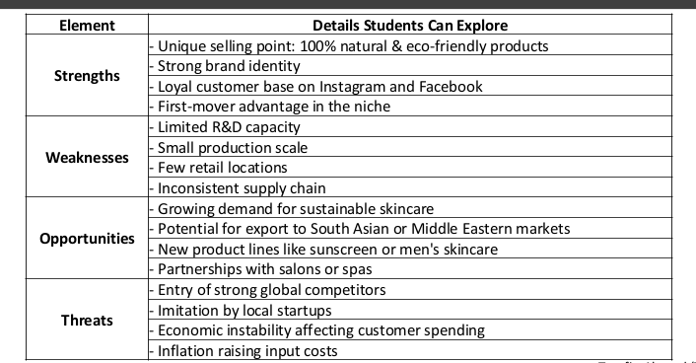

# **Competitive analysis:**

Competitors are rival industries that either make the same products as yours or substitute products which makes your products obsolete. There are 3 types of competitors. They are:

Direct competitors: These companies make the same products as our company, therefore customers can choose to buy from a different place than ours.

Indirect competitors: These companies make products that are not the same as ours but make substitutes of our products. Customers tend to buy these products when they don’t care about the types of products that we make.

Future competitors: These are threats that we must take into consideration while writing our business plan.

A competitive analysis is an analysis of different types of competitors in varying fields. Let’s take “Fresh Cola” and analyze different competitors and how much advantage they have.

|  | | Convenience | Customizable | Availability | Domestic/ Foreign | Recognition | Experience |
| --- | --- | --- | --- | --- | --- | --- | --- |
| **Fresh Cola** | | Even | Even | Slightly High | Domestic | Slightly Low | Disadv |
| Direct | Coca Cola | Disadv | Even | High | Foreign | High | Adv |
| Max Cola | Even | Even | Slightly low | Domestic | Low | Disadv |
| Indirect | Jibon | Even | High | High | Domestic | High | Disadv |
| Speed | Even | High | High | Domestic | High | Disadv |

# 

Marketing Principle

The Marketing 4Ps are four key things a business can control to promote its brand and give value to its customers. All four should match the company’s overall goals and strategy.

Product:

A product is what a company offers to meet customer needs. The product can be both tangible (ie phones) and intangible (ie services)

Price:  
Price is the amount of money customers pay to buy a product. It’s a very important part of marketing because it affects how much profit a company can make.

Most businesses use one of two ways to set prices:

* Cost-based pricing: The price is set by adding a profit margin to the cost of making the product. It’s easy to use but doesn’t think about what customers are willing to pay. It can also be risky if costs change.
* Value-based pricing: The price is based on what customers believe the product is worth. It focuses on customer opinions and market demand. This method is better because it reflects real value and can increase profits.

Promotion:

Promotion means the steps a company takes to tell customers about its product. It helps people learn about the brand, become interested, and decide to buy. Startups usually use low-cost but effective methods to reach their audience. Common promotional tools:

➔ Advertising (digital, print, outdoor)

➔ Sales promotions (discounts, offers)

➔ Social media marketing

➔ Public relations

➔ Viral or guerrilla marketing

Place:  
Place, also called distribution, is about how a product gets from the company to the customer. It includes all the steps to deliver the product to the end user.

A business must choose how to sell its product:

* Selling Direct: Through its own website or physical store.
* Selling Through Intermediaries: Using others like distributors, retailers, or online marketplaces

The goal is to make sure the product is easy for customers to find and buy.

Ratio

# **Liquidity Ratio:**

Liquidity ratios measure the short-term ability of the enterprise to pay its maturing obligations and to meet unexpected needs for cash. Bankers are interested in assessing liquidity.

# **Current Ratio:**

The current ratio expresses the relationship of current assets to current liabilities. It is used for evaluating a company’s short term debt paying ability.

# **Acid Test Ratio:**

The current ratio measures a company's short-term liquidity — its ability to pay off current liabilities without relying on inventory.

# **Debt to Asset Ratio:**

The debt to assets ratio measures the percentage of the total assets provided by creditors. It is used for evaluating a company’s ability to withstand losses without losing the creditor’s money.

# **Debt to Equity Ratio:**

The debt to equity ratio measures the percentage of the total assets provided by creditors. It is used for evaluating a company’s ability to withstand losses without losing the creditor’s money.

# **Return on Assets Ratio:**

The return to assets ratio measures the overall profitability of assets in terms of the rate earned on each dollar invested.

# **Profit Margin Ratio:**

The profit margin ratio is a measure of the percentage of each dollar of sales that results in income.

# **Gross Profit Rate:**

This rate measures a company’s ability to maintain an adequate selling price above its cost.

SRF Company

Statement of Financial Position

For the year ended as at 31 December 2023 & 2022

| Particulars | 2023  BDT | 2022  BDT |
| --- | --- | --- |
| **Assets** |  |  |
| Cash | 15,000 | 10,000 |
| Accounts Receivable | 25,000 | 20,000 |
| Inventory | 35,000 | 30,000 |
| Total Current Assets | 75,000 | 60,000 |
| Property, Plant & Equipment | 55,000 | 50,000 |
| Total Assets | 130,000 | 110,000 |
| **Liabilities** |  |  |
| Accounts Payable | 20,000 | 15,000 |
| Short-Term Debt | 15,000 | 10,000 |
| Total Current Liabilities | 35,000 | 25,000 |
| Long-Term Debt | 35,000 | 30,000 |
| Total Liabilities | 70,000 | 55,000 |
| **Equity** |  |  |
| Retained Earnings | 40,000 | 30,000 |
| Common Stock | 20,000 | 25,000 |
| Total Equity | 60,000 | 55,000 |
| **Total Liabilities & Equity** | 130,000 | 110,000 |

SRF Company

Statement of profit or loss and other comprehensive income

For the year ended as at 31 December 2023 & 2022

| **Particulars** | 2023 (BDT) | 2022 (BDT) |
| --- | --- | --- |
| Revenue | 180,000 | 150,000 |
| Cost of the service | 105,000 | 90,000 |
| **Gross Profit** | 75,000 | 60,000 |
| Operating Expenses | 35,000 | 30,000 |
| **Net Income** | 40,000 | 30,000 |

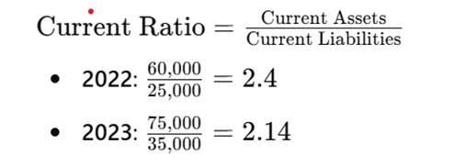

Ideally, a current ratio of 2:1 is considered healthy. The current ratio slightly decreased in 2023 from 2022. While both ratios are above 2.0, a decrease suggests slightly tighter liquidity.

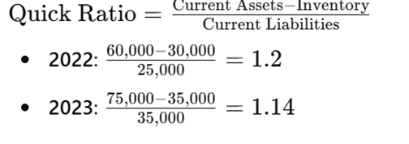 Also known as acid test ratio

ȰPrepaid expense is not present in the tableȰ

Ideally, an acid-test ratio of 1:1 is considered healthy. The acid test ratio excludes inventory as assets are easier to liquidate. Both ratios are above 1, a decrease suggests the loss was mostly in assets, rather than inventory.

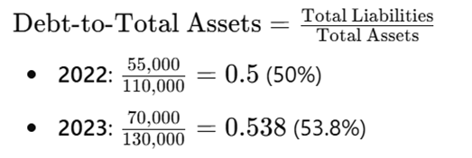

Ideally, a debt-to-asset ratio of 50-60% is considered healthy. Both debts are between the ideal amount but an increase in the ratio suggests a minimal financial risk.

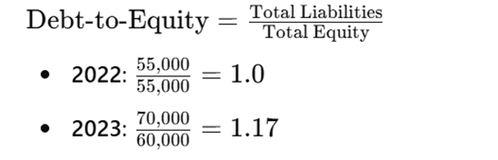

Ideally a debt-to-equity ratio of 1:1 or lower is considered healthy. In 2023, the debt percentage rose slightly indicating a reduction in financial flexibility.

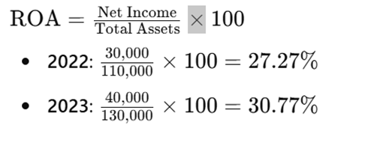

Ideally, a ROA of 10-15% is considered healthy. The ROA reflects how efficiently the company uses its assets to generate profit. Both ROA are higher than the expected amount and in 2023 it increased indicating strong asset utilization.

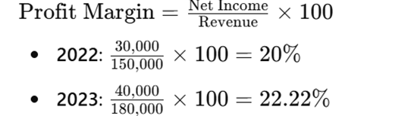

Ideally, a profit margin ratio of 10-20% is considered healthy. The profit margin reflects how efficiently the company uses its assets to generate profit. The profit margin improved from 20% in 2022 to 22.22% in 2023. Both years exceed the benchmark of 10-20%, showing strong profitability driven by cost control or pricing strategies.

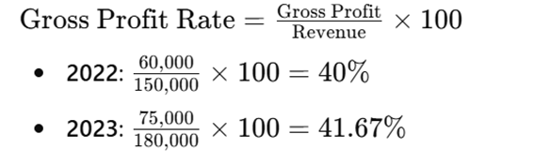

For manufacturing, a benchmark might be around 35-40%. Indicates the efficiency of production and cost control. The gross profit rate slightly improved, reflecting better cost management or higher sales prices. It exceeds the benchmark of 35-40%, showing a healthy margin.